Ekaterina Lyapina (Student ID 160984099)

Msc Big Data Science

DMSN Coursework 1: Crawling Twitter

For this coursework an application was created through Twitters app dashboard:

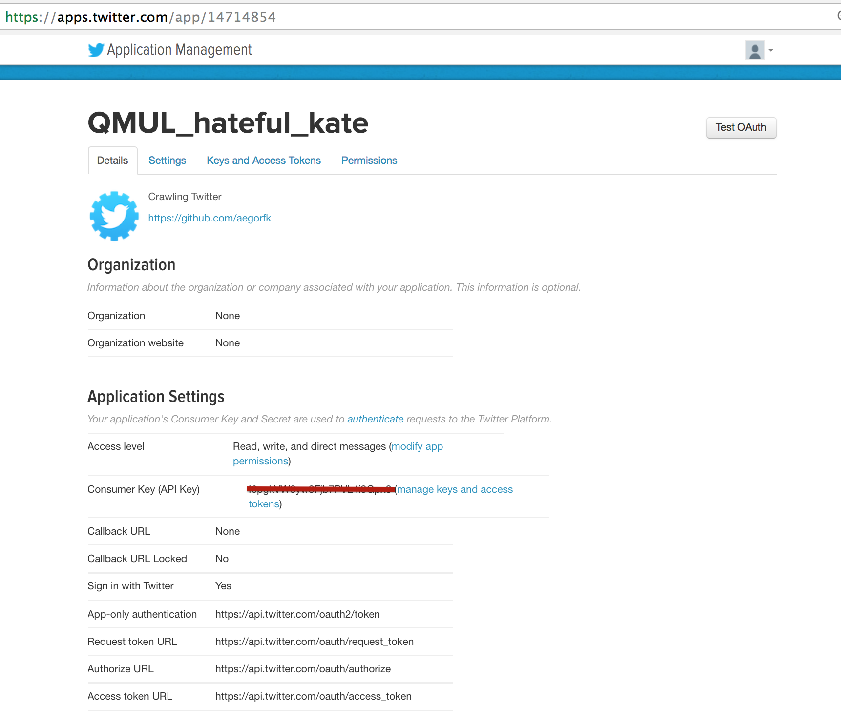

The crawler was written using Python. An access can be made using the following code:

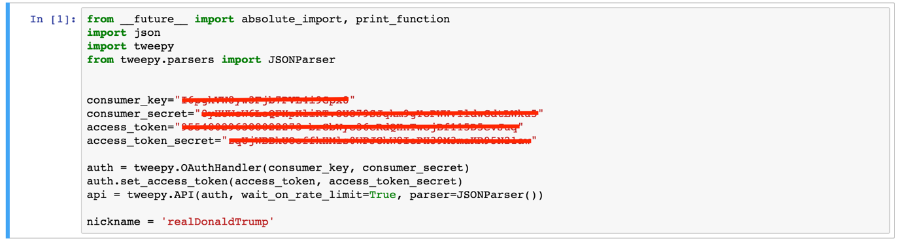

Twitter API profiles endpoints were requested:

# parsing profile of the user

user = api.get_user(nickname)

user = json.dumps(user)

print(user)

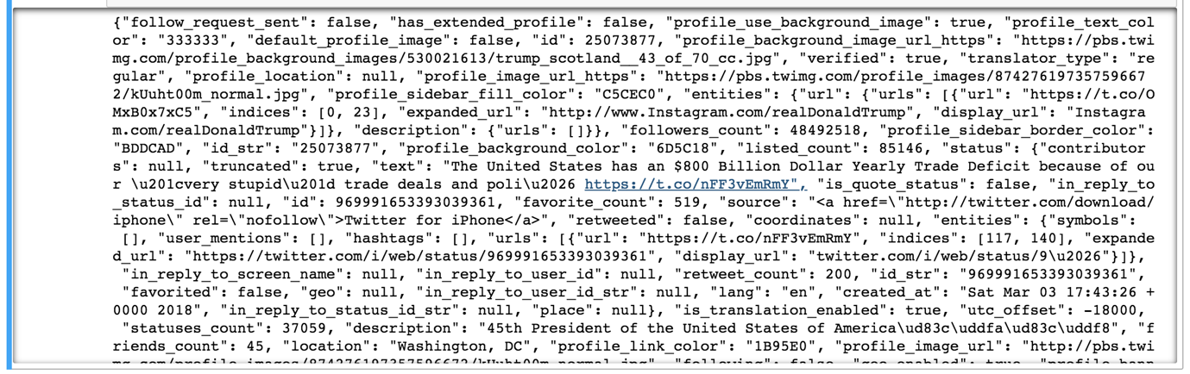

# parsing timeline of the user

timeline = api.user_timeline(nickname, count=1)

timeline = json.dumps(timeline)

print(timeline)

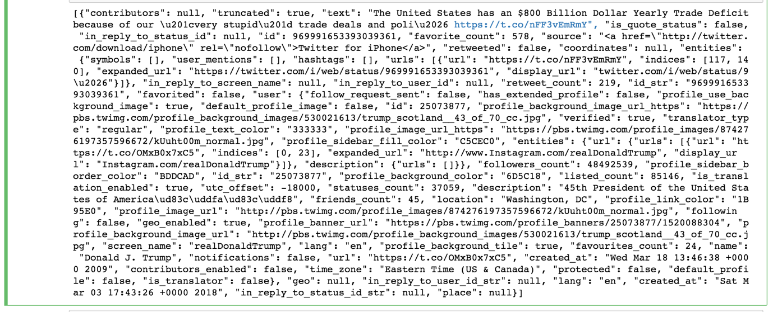

#parsing followers of the user

followers = api.followers(nickname, count=1)

followers = json.dumps(followers)

print(followers)

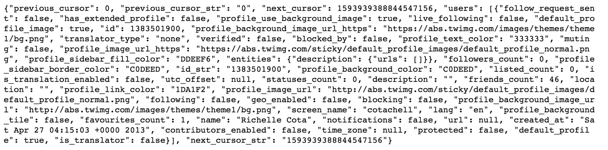

friends = api.friends(nickname, count=1)

friends = json.dumps(friends)

print(friends)

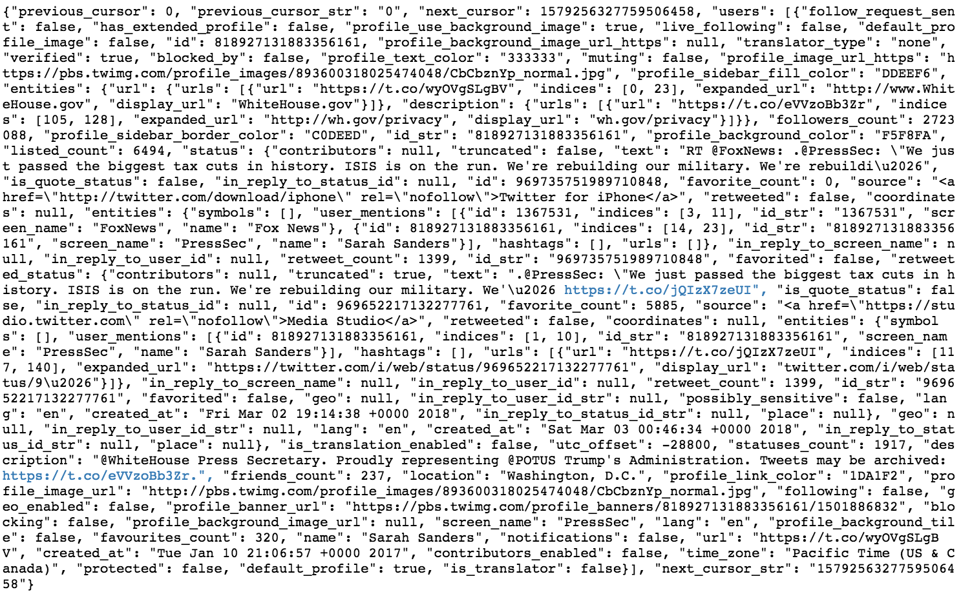

# parsing friends ids to see the profile individually

friends_list = api.friends_ids(nickname)

friends_list = friends_list["ids"]

print(friends_list)

print(len(friends_list))

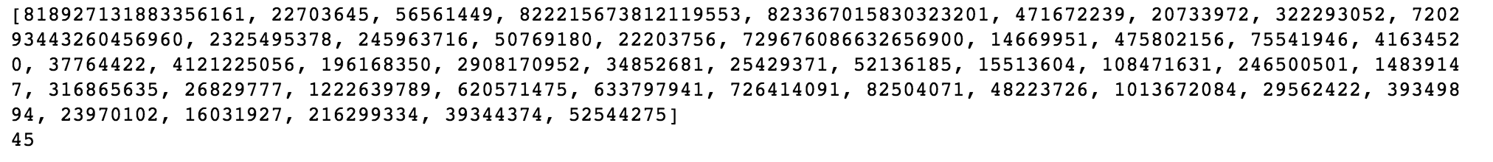

# loop through each friens by id and download profile

type(friends_list)

l = []

for i in friends_list:

# parsing profile of each user

user = api.get_user(i)

user = json.dumps(user)

l.append(user)

# print the first friend's profile as an example

print(l[0])

